Subject: Discrete Mathematics
EXERCISES - CHAPTER 4: Induction and Recursion

Book: Discrete Mathematics and Its Applications, 6th Edition
Author: Kenneth H. Rosen
Publisher: McGraw-Hill International Edition
Total: 8 exercises

Page | Exercises
279 | 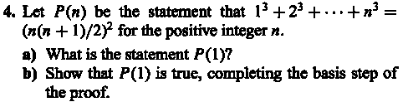  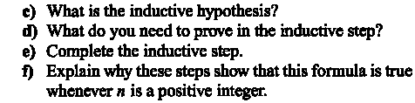
280 |   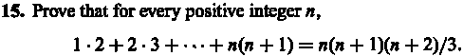  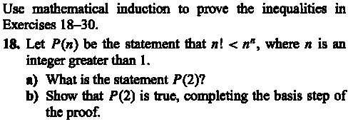  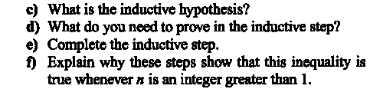
308 | 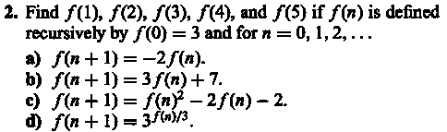  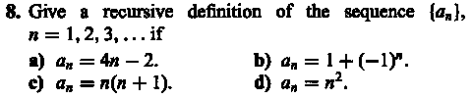  Let f_{n} is the nth of Fibonacci number (1, 1, 2, 3, 5, 8, 13,…)
209 | 